B.H. COLLEGE
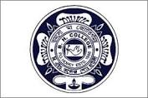
HOWLY:: BARPETA::ASSAM
DEPARTMENT: Education | DATE: 02-05-2023
No. of Students/Participants | 81
Title of the Programme
Farewell Programme of B.A. 6th Semester and PG 4th Semester Programme

Description of the Programme
Departmental farewell programme held on 2nd May, 2023 at Room No 18, B.H.College. Students from both PG and UG courses participated in the programme with colourful programme. The students of PG4th semester and UG 6th semester were felicitated. The teachers of the department also took part in the function. Dr. Bhushan ch. Pathak, Principal, B.H.College, addressed the meeting.

